Project Planning Phase
Project Planning Template (Product Backlog, Sprint Planning, Stories, Story points)

Date | 15 February 2025
Team ID | LTVIP2026TMIDS80646
Project Name | Dog Breed Identification using Transfer Learning (VGG19) with Flask Deployment
Maximum Marks | 5 Marks

Product Backlog, Sprint Schedule, and Estimation (4 Marks)
Sprint | Functional Requirement (Epic) | User Story No. | User Story / Task | Story Points | Priority | Team Members
Sprint-1 | Dataset Preparation | USN-1 | As a developer, I can collect and organize dog image datasets into class folders. | 2 | High | Team
Sprint-1 |  | USN-2 | As a developer, I can preprocess images (resize, normalize) for model training. | 3 | High | Team
Sprint-1 | Model Setup | USN-3 | As a developer, I can set up transfer learning with VGG19. | 5 | High | Team
Sprint-2 | Model Training | USN-4 | As a developer, I can train and validate the CNN model on the dataset. | 5 | High | Team
Sprint-2 | Web Application | USN-5 | As a user, I can upload a dog image through a web interface. | 3 | High | Team
Sprint-2 |  | USN-6 | As a user, I can view predicted breed and confidence score. | 3 | Medium | Team
Sprint-3 | Integration & Testing | USN-7 | As a developer, I can integrate the trained model with the Flask backend. | 5 | High | Team
Sprint-3 |  | USN-8 | As a user, I can re-upload another image for new predictions. | 2 | Low | Team

Project Tracker, Velocity & Burndown Chart: (4 Marks)

Sprint | Total Story Points | Duration | Sprint Start Date | Sprint End Date (Planned) | Story Points Completed (as on Planned End Date) | Sprint Release Date (Actual)
Sprint-1 | 10 | 7 Days | 15 Feb 2025 | 21 Feb 2025 | 10 | 21 Feb 2025
Sprint-2 | 11 | 7 Days | 22 Feb 2025 | 28 Feb 2025 | 11 | 28 Feb 2025
Sprint-3 | 7 | 6 Days | 01 Mar 2025 | 06 Mar 2025 | 7 | 06 Mar 2025

Velocity:
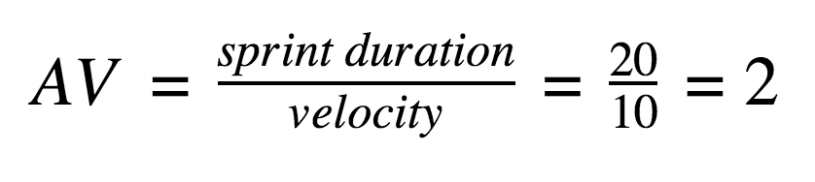
Assume each sprint duration is 7 days.
- Sprint-1 Velocity: 10 story points
- Sprint-2 Velocity: 11 story points
- Sprint-3 Velocity: 7 story points
Average Velocity (AV):
AV = (10 + 11 + 7) / 3 ≈ 9.3 story points per sprint
If needed per day:≈ 1.3 story points/day

Burndown Chart:
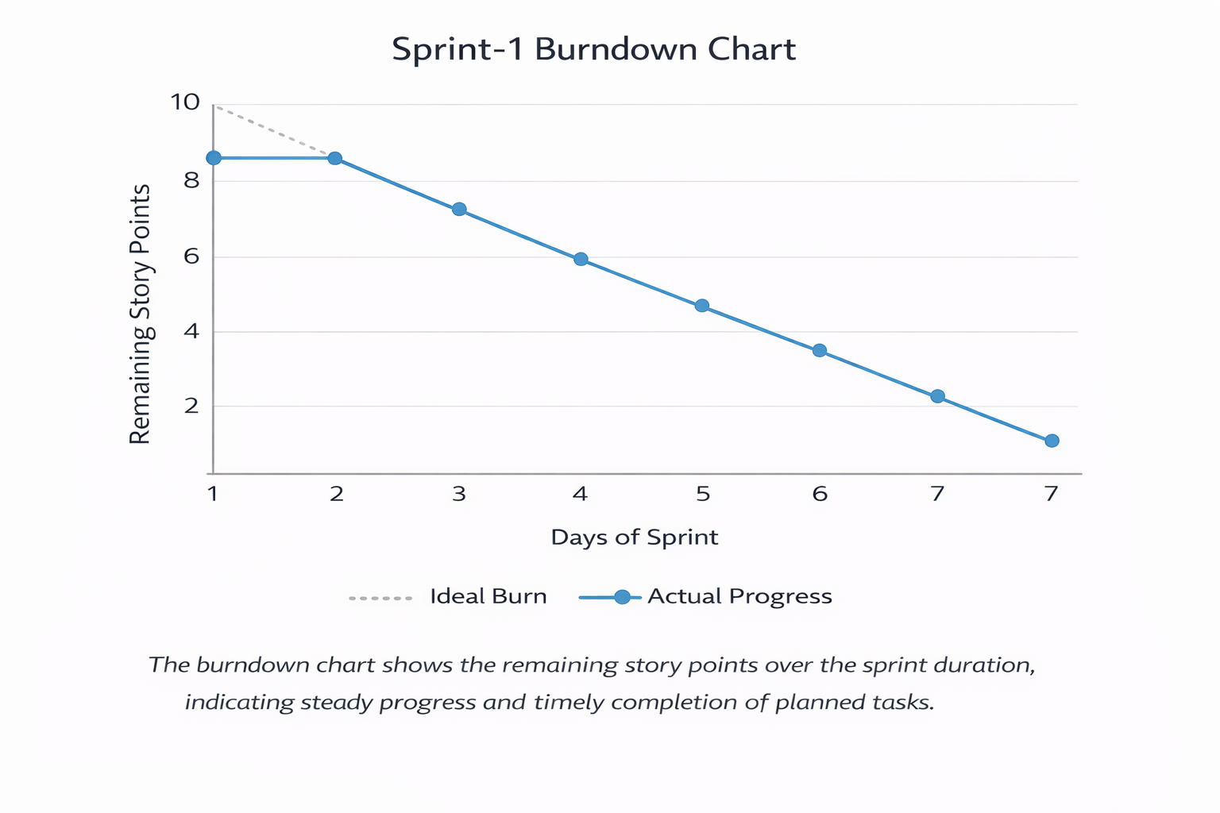
https://www.visual-paradigm.com/scrum/scrum-burndown-chart/
https://www.atlassian.com/agile/tutorials/burndown-charts

Reference:
https://www.atlassian.com/agile/project-management
https://www.atlassian.com/agile/tutorials/how-to-do-scrum-with-jira-software
https://www.atlassian.com/agile/tutorials/epics
https://www.atlassian.com/agile/tutorials/sprints
https://www.atlassian.com/agile/project-management/estimation
https://www.atlassian.com/agile/tutorials/burndown-charts

